**SECTION GE**

**DUPLEX FUEL OIL FILTER**

CONTENTS

|  |  |
| --- | --- |
|  | Chapter |
| Description | 1 |
| Servicing | 2 |
| Servicing Change-over Valve | 3 |

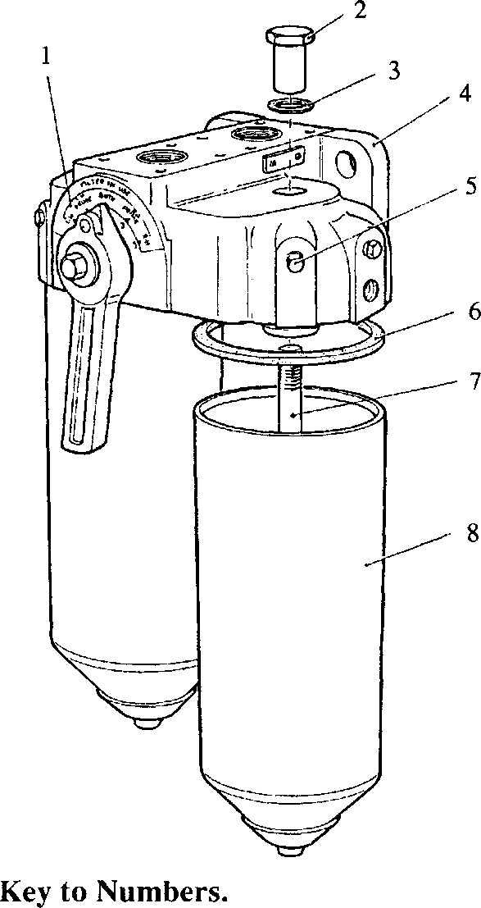

15 4

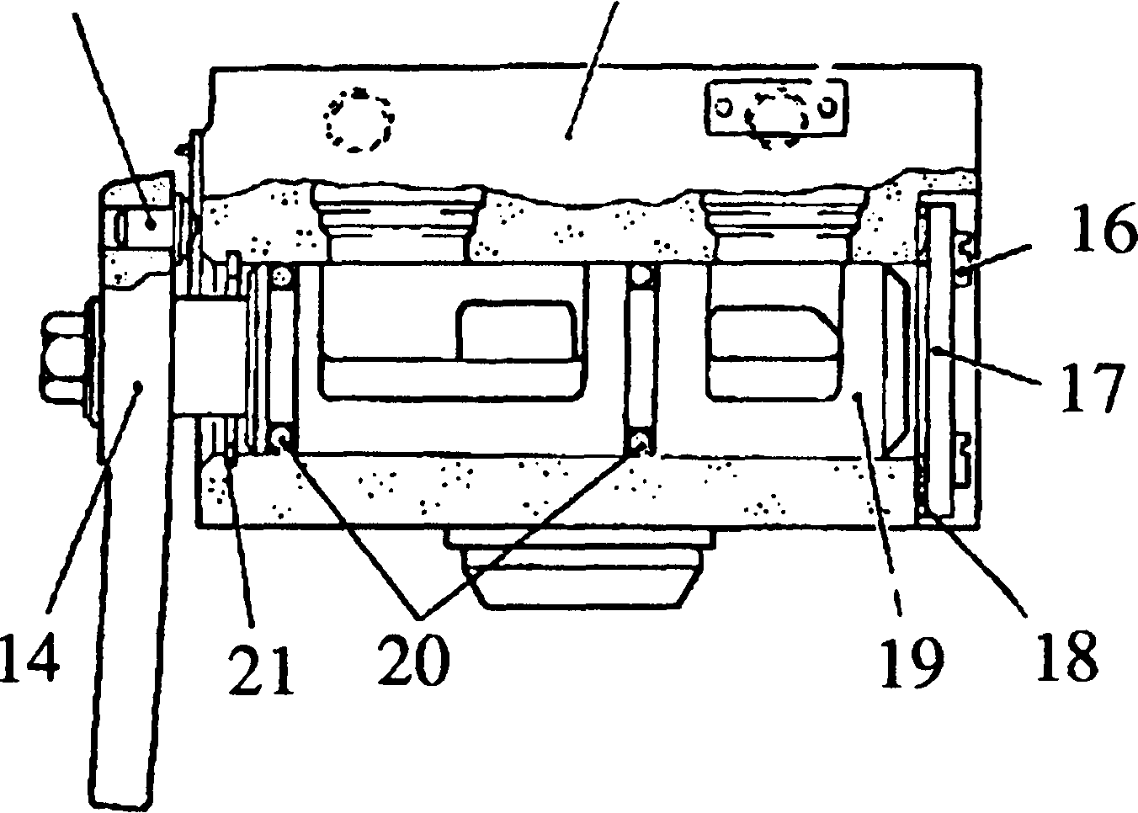

9

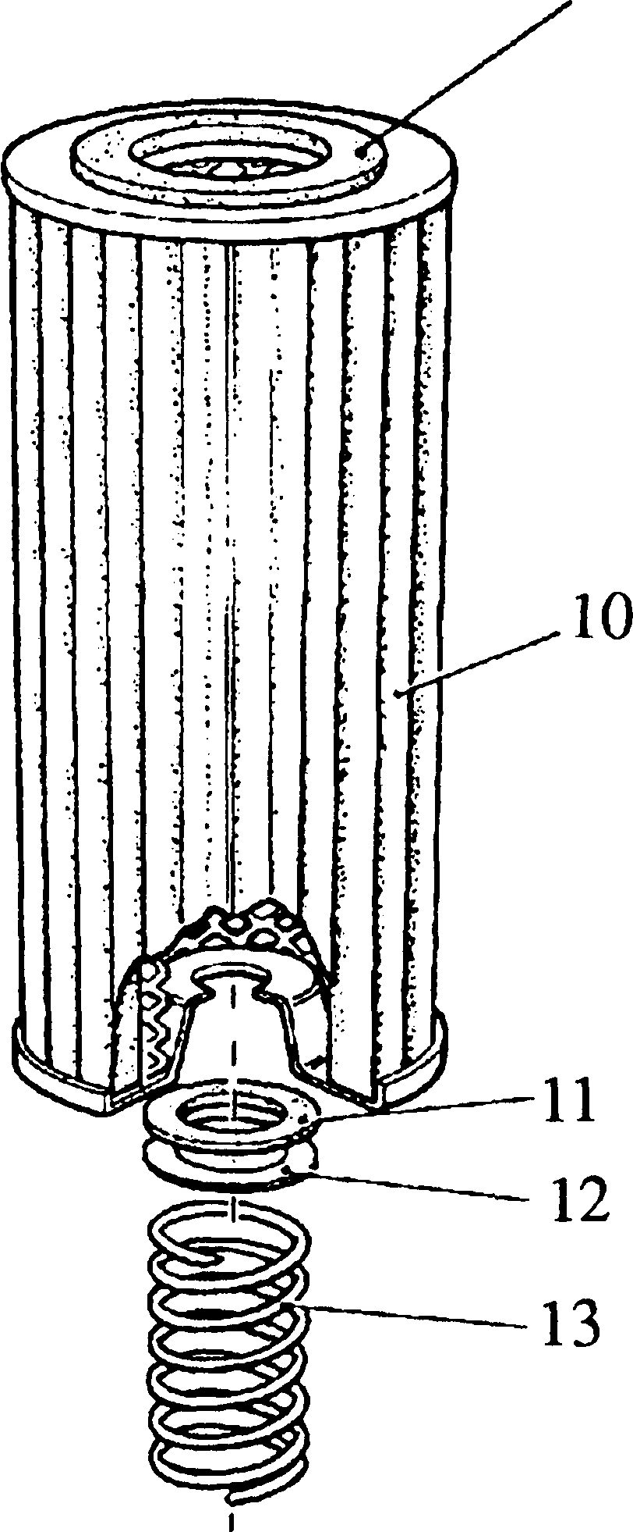

**SPD00274**

Plain washer Spring

|  |  |  |
| --- | --- | --- |
| 1. | Indicator plate | 12. |
| 2. | Capnut | 13. |
| 3. | Fibre washer | 14. |
| 4. | Head casting | 15. |
| 5. | Vent plug | 16. |
| 6. | Joint ring | 17. |
| 7. | Centre bolt | 18. |
| 8. | Filter case | 19. |
| 9. | Joint | 20. |
| 10. | Cartridge element | 21. |
| 11. | Seal |  |

Handle and pointer

Locking plunger

Setscrew

Endplate

Gasket

Valve plug

'O' rings

Circlip

Fig GE.l Duplex fuel oil Filter.

CHAPTER 1

DUPLEX FUEL OIL FILTER.

Description.

1. The duplex fuel oil filter comprises two separate filtration units secured to a common ported head casting (4)(Fig FE.l). A change-over valve, fitted to the head casting enables one filtration unit to be serviced while the other is in use. The change-over valve is fitted with a handle and pointer (14) to indicate the filtration unit in use. The positions on indicator plate (1) are:-
2. Left hand filter in use.
3. Prime right hand filter, left hand filter in use.
4. Both filters in use.
5. Prime left hand filter, right hand filter in use.
6. Right hand filter in use.

The handle and pointer are retained in the indicated position by a locking plunger (15).

CHAPTER 2

SERVICING

Dismantling.

1. Turn the handle and pointer (14), to the filtration unit to be used and isolate the filtration unit to be serviced.
2. Support filter case (8) of the filter to be serviced. Release and remove capnut (2) and fibre washer (3) and remove filter case complete with cartridge element (10).
3. Empty the filter case and remove and discard the cartridge element.

NOTE The cartridge element has a cemented top joint (9) which cannot be removed. Both cartridge and joint must be discarded.

1. Remove joint ring (6) from head casting (4) and discard.
2. Remove seal (11), washer (12) and spring (13) from the filter case.

Cleaning and Inspection

1. Wash all metal components in a suitable solvent, ie. kerosene or lead-free petrol, and dry thoroughly before reassembly.
2. Examine all joint faces for burrs and indentations which may affect sealing.

Assembling and Fitting

NOTE All joints and 'O' rings must befitted dry.

1. Refit spring (13), washer (12) and a new seal (11) onto centre bolt (7).
2. Check new cartridge element (10) to ensure that joint (9) is cemented securely in

place, and fit it over centre bolt (7) ensuring correct seating in filter case (8).

1. Fit a new joint ring (6) into head casting (4).
2. Fit filter case (8) to head casting (4) and secure with capnut (2) and new fibre

washer (3). Tighten capnut to a torque of 10 lb/ft (13.5 Nm).

1. Turn handle and pointer (14) to position to prime filter which has been serviced.
2. Open vent plug (5) to bleed the filter of air. Close vent plug immediately air-free fuel flows from the vent.
3. Return valve handle to filter in use.

CHAPTER 3

SERVICING CHANGE-OVER VALVE

NOTE The change-over valve unit mounted in the filter head casting is a simple plug assembly. No maintenance is required other than to renew the 'O’ rings during major overhaul.

1. Drain the fuel system.
2. Remove the inlet and outlet pipes to the filter head casting.
3. Remove filter casings (Chapter 2).
4. Support head casting (4) and remove the nuts, setscrews and spring washers securing the head casting to the mounting bracket.
5. Release and remove setscrews (16) and remove endplate (17), to break the suction for removal of valve plug (19).
6. Remove the setscrew and washer securing handle and pointer (14). Mark the position of the handle to valve plug (19), and using a slight rocking motion, remove the handle and pointer.
7. Remove internal circlip (21) and remove valve plug (19) by tapping gently with a wooden drift from the rear of the valve plug.
8. Remove 'O' rings (20) and discard.
9. Clean and inspect valve plug for wear. Renew if necessary.

Assembling and Fitting

NOTE All joints and 'O' rings must befitted dry.

1. Fit new 'O' rings (20) to valve plug (19).
2. Smear the 'O' rings with petroleum jelly and insert valve plug into head casting (4), and fit internal circlip (21).
3. Using a new gasket (18) fit endplate (17) and secure with setscrews (16).
4. Refit handle and pointer (14) to valve plug (19) ensuring that alignment marks are correctly positioned, and secure with the setscrew and plain washer.
5. Refit head casting (4) to the mounting bracket.
6. Refit filter casings (Chapter 2).
7. Refit inlet and outlet piping to head casting (4).
8. Restore fuel supply. Prime and vent the system.